April 12, 2026, Remnant Church 9:00 AM
* Call to Worship: (1 Chronicles 16:29)
* Prayer of Invocation
* Singing: Hymn 6 – All People That On Earth Do Dwell
*God’s Greeting:
The Disciple's Prayer (Lord's Prayer) – Page 120
The Reading of God's Law: Mark 12: 28-31
The General Confession
- Public (Unison)- Page 120
- Individual (Silently)
- Prayer (Minister)
* Singing: Hymn 8 –Amazing Grace!
The Apostle's Creed (Unison) – Page 121
Congregational Prayer
- Individual and Pastoral
The Gloria Patri – Page 121
* Singing: Hymn 15 – Begin, My Tongue

Message: ROMANS 8:1-4, Sermon, and Prayer

* Singing: Hymn 9 – And Can It Be That I Should Gain
*Doxology: Page 121 - Praise God from whom all blessings flow
*Benediction
*if you are able, please stand
CALL TO WORSHIP: 1 CHRONICLES 16:29

Ascribe to the Lord the glory due His name; bring an offering and come before Him. Worship the Lord in the splendor of His holiness.

READING OF THE LAW: MARK 12: 28-31

28 One of the teachers of the law came and heard them debating. Noticing that Jesus had given them a good answer, he asked Him, “Of all the commandments, which is the most important?”

29 “The most important one,” answered Jesus, “is this: ‘Hear, O Israel: The Lord our God, the Lord is one. 30 Love the Lord your God with all your heart and with all your soul and with all your mind and with all your strength.’ 31 The second is this: ‘Love your neighbor as yourself.’ There is no commandment greater than these.”

SERMON TEXT: ROMANS 8:1-4
1 Therefore, there is now no condemnation for those who are in Christ Jesus, 2 because through Christ Jesus the law of the Spirit who gives life has set you free from the law of sin and death. 3 For what the law was powerless to do because it was weakened by the flesh, God did by sending his own Son in the likeness of sinful flesh to be a sin offering. And so, he condemned sin in the flesh, 4 in order that the righteous requirement of the law might be fully met in us, who do not live according to the flesh but according to the Spirit.

CHURCH INFORMATION

Meeting Place: Pella Memorial Building
829 Broadway St Pella, IA 50219

Time: 9:00 AM

Phone: 641.858.6985

Email: pastor@trinityremnant.org

Parsonage Address: 535 Peoria Cross Street Pella, IA 50219

Website: www.trinityremnant.org

Our Commitment to God:

Doing ANYTHING for Him,
Going ANYWHERE for Him, and
Working ANYTIME for Him

Pastor: Benjamin Anum-Higher

TRINITY REMNANT CHURCH

PELLA, IA

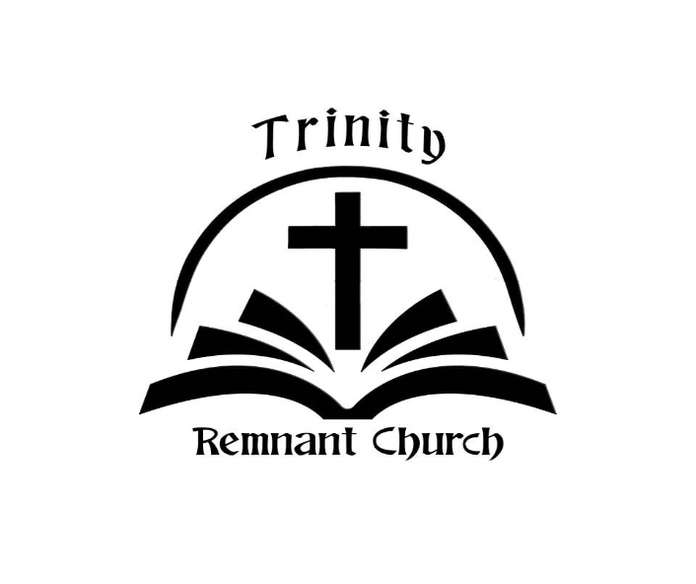

APRIL 12, 2026

ROMANS 8:1-4

