April 26, 2026, Remnant Church 9:00 AM
* Call to Worship: (Hebrews 12:28-29)
* Prayer of Invocation
* Singing: Hymn 24 –, Come Thou Fount
*God’s Greeting:
The Disciple's Prayer (Lord's Prayer) – Page 120
The Reading of God's Law: Mark 12: 28-31
The General Confession
- Public (Unison)- Page 120
- Individual (Silently)
- Prayer (Minister)
* Singing: Hymn 25 – Come, Thou Long Expected Jesus
The Apostle's Creed (Unison) – Page 121
Congregational Prayer
- Individual and Pastoral
The Gloria Patri – Page 121
* Singing: Hymn 21 – Christians, Awake

Message: ROMANS 8:12-14, Sermon, and Prayer

* Singing: Hymn 23 –Come, Thou Almighty King
*Doxology: Page 121 - Praise God from whom all blessings flow
*Benediction
*if you are able, please stand
CALL TO WORSHIP: HEBREWS 12:28-29

²⁸ Therefore, since we are receiving a kingdom that cannot be shaken, let us be thankful, and so worship God acceptably with reverence and awe, ²⁹ for our “God is a consuming fire.”

READING OF THE LAW: MARK 12: 28-31

28 One of the teachers of the law came and heard them debating. Noticing that Jesus had given them a good answer, he asked Him, “Of all the commandments, which is the most important?”
29 “The most important one,” answered Jesus, “is this: ‘Hear, O Israel: The Lord our God, the Lord is one. 30 Love the Lord your God with all your heart and with all your soul and with all your mind and with all your strength.’ 31 The second is this: ‘Love your neighbor as yourself.’ There is no commandment greater than these.”

SERMON TEXT: ROMANS 8:12-14
12 Therefore, brothers and sisters, we have an obligation—but it is not to the flesh, to live according to it. 13 For if you live according to the flesh, you will die; but if by the Spirit you put to death the misdeeds of the body, you will live.
14 For those who are led by the Spirit of God are the children of God.

CHURCH INFORMATION

Meeting Place: Pella Memorial Building
829 Broadway St Pella, IA 50219

Time: 9:00 AM

Phone: 641.858.6985

Email: pastor@trinityremnant.org

Parsonage Address: 535 Peoria Cross Street Pella, IA 50219

Website: www.trinityremnant.org

Our Commitment to God:

Doing ANYTHING for Him,
Going ANYWHERE for Him, and
Working ANYTIME for Him

Pastor: Benjamin Anum-Higher

TRINITY REMNANT CHURCH

PELLA, IA

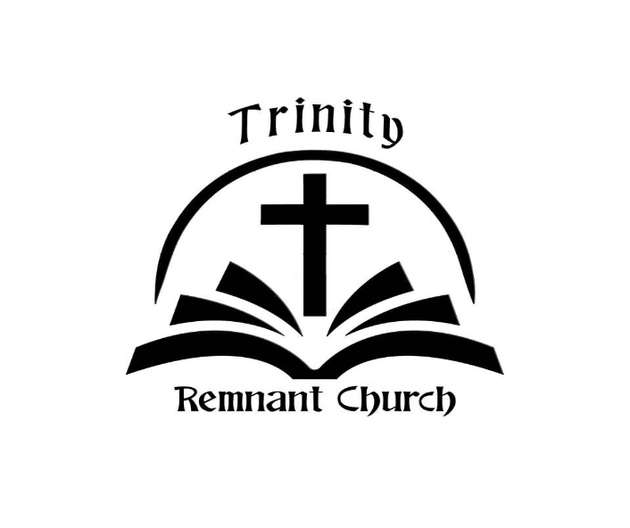

APRIL 26, 2026

ROMANS 8:12-14

