January 11, 2026 Remnant Church 9:00 AM
* Call to Worship: (Psalm 150: 1-2)
* Prayer of Invocation
* Singing: Hymn 55 – Immortal Invisible God
*God’s Greeting:
The Disciple's Prayer (Lord's Prayer) – Page 120
The Reading of God's Law: Mark 12: 28-31
The General Confession
- Public (Unison)- Page 120
- Individual (Silently)
- Prayer (Minister)
* Singing: Hymn 33 – God Be Merciful To Me
The Apostle's Creed (Unison) – Page 121
Congregational Prayer
- Individual and Pastoral
The Gloria Patri – Page 121
* Singing: Hymn 1 – A Debtor To Mercy Alone

Message: ROMANS 4, Sermon, and Prayer

* Singing: Hymn 84 – Our Great Savior
*Doxology: Page 121 - Praise God from whom all blessings flow
*Benediction
*if you are able, please stand
CALL TO WORSHIP: PSALM 150: 1-2

1 Praise the Lord. Praise God in His sanctuary;
praise Him in His mighty heavens.
2 Praise Him for His acts of power;
praise Him for His surpassing greatness.

READING OF THE LAW: MARK 12: 28-31

28 One of the teachers of the law came and heard them debating. Noticing that Jesus had given them a good answer, he asked Him, “Of all the commandments, which is the most important?”

29 “The most important one,” answered Jesus, “is this: ‘Hear, O Israel: The Lord our God, the Lord is one. 30 Love the Lord your God with all your heart and with all your soul and with all your mind and with all your strength.’ 31 The second is this: ‘Love your neighbor as yourself.’ There is no commandment greater than these.”

SERMON TEXT: ROMANS 4

CHURCH INFORMATION

Meeting Place: Pella Memorial Building
829 Broadway St Pella, IA 50219

Time: 9:00 AM

Phone: 641.858.6985

Email: pastor@trinityremnant.org

Parsonage Address: 535 Peoria Cross Street Pella, IA 50219

Website: www.trinityremnant.org

Our Commitment to God:

Doing ANYTHING for Him,
Going ANYWHERE for Him, and
Working ANYTIME for Him

Pastor: Benjamin Anum-Higher

TRINITY REMNANT CHURCH

PELLA, IA

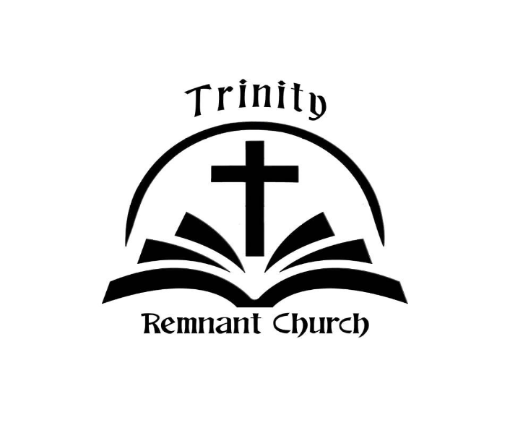

JANUARY 11, 2026

ROMANS 4

