April 5, 2026, Remnant Church 9:00 AM
* Call to Worship: (John 4:23-24)
* Prayer of Invocation
* Singing: Hymn 4 –All Creatures Of Our God And King
*God’s Greeting:
The Disciple's Prayer (Lord's Prayer) – Page 120
The Reading of God's Law: Mark 12: 28-31
The General Confession
- Public (Unison)- Page 120
- Individual (Silently)
- Prayer (Minister)
* Singing: Hymn 7 –All The Way My Savior Leads Me
The Apostle's Creed (Unison) – Page 121
Congregational Prayer
- Individual and Pastoral
The Gloria Patri – Page 121
* Singing: Hymn 2 – A Mighty Fortress Is Our God

Message: ROMANS 7:14-25, Sermon, and Prayer

* Singing: Hymn 3 – Alas! And Did My Savior Bleed
*Doxology: Page 121 - Praise God from whom all blessings flow
*Benediction
*if you are able, please stand
CALL TO WORSHIP: JOHN 4: 23-24

²³ Yet a time is coming and has now come when the true worshipers will worship the Father in the Spirit and in truth, for they are the kind of worshipers the Father seeks. ²⁴ God is spirit, and His worshipers must worship in the Spirit and in truth.”

SERMON TEXT: ROMANS 7:14 - 25
¹⁴ We know that the law is spiritual; but I am unspiritual, sold as a slave to sin. ¹⁵ I do not understand what I do. For what I want to do I do not do, but what I hate I do. ¹⁶ And if I do what I do not want to do, I agree that the law is good. ¹⁷ As it is, it is no longer I myself who do it, but it is sin living in me. ¹⁸ For I know that good itself does not dwell in me, that is, in my sinful nature. For I have the desire to do what is good, but I cannot carry it out. ¹⁹ For I do not do the good I want to do, but the evil I do not want to do—this I keep on doing. ²⁰ Now if I do what I do not want to do, it is no longer I who do it, but it is sin living in me that does it.
²¹ So I find this law at work: Although I want to do good, evil is right there with me. ²² For in my inner being I delight in God’s law; ²³ but I see another law at work in me, waging war against the law of my mind and making me a prisoner of the law of sin at work within me. ²⁴ What a wretched man I am! Who will rescue me from this body that is subject to death? ²⁵ Thanks be to God, who delivers me through Jesus Christ our Lord!
So then, I myself in my mind am a slave to God’s law, but in my sinful nature a slave to the law of sin.

CHURCH INFORMATION

Meeting Place: Pella Memorial Building
829 Broadway St Pella, IA 50219

Time: 9:00 AM

Phone: 641.858.6985

Email: pastor@trinityremnant.org

Parsonage Address: 535 Peoria Cross Street Pella, IA 50219

Website: www.trinityremnant.org

Our Commitment to God:

Doing ANYTHING for Him,
Going ANYWHERE for Him, and
Working ANYTIME for Him

Pastor: Benjamin Anum-Higher

TRINITY REMNANT CHURCH

PELLA, IA

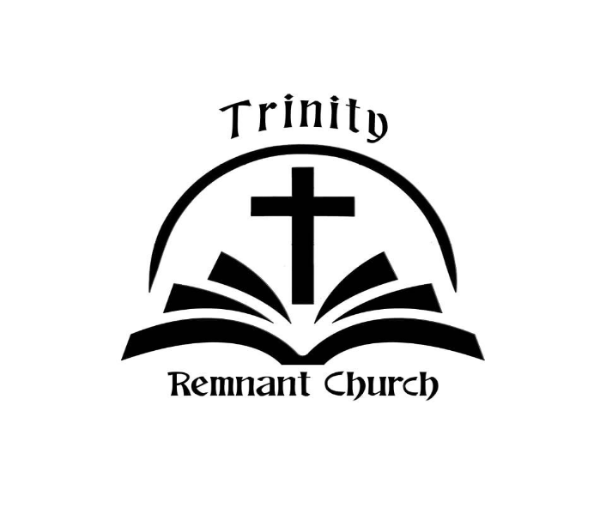

APRIL 5, 2026

ROMANS 7:14-25

