February 22, 2026, Remnant Church 9:00 AM
* Call to Worship: (Psalm 136: 1)
* Prayer of Invocation
* Singing: Hymn 89 –Praise the Lord! Ye Heavens
*God’s Greeting:
The Disciple's Prayer (Lord's Prayer) – Page 120
The Reading of God's Law: Mark 12: 28-31
The General Confession
- Public (Unison)- Page 120
- Individual (Silently)
- Prayer (Minister)
* Singing: Hymn 59 –Jesus Paid It All
The Apostle's Creed (Unison) – Page 121
Congregational Prayer
- Individual and Pastoral
The Gloria Patri – Page 121
* Singing: Hymn 61 –Jesus, the very thought of Thee

Message: ROMANS 6:1-4, Sermon, and Prayer

* Singing: Hymn 60 – Jesus Shall Reign
*Doxology: Page 121 - Praise God from whom all blessings flow
*Benediction
*if you are able, please stand
CALL TO WORSHIP: PSALM 136: 1

1 Give thanks to the Lord, for He is good, for His steadfast love endures forever.

READING OF THE LAW: MARK 12: 28-31

28 One of the teachers of the law came and heard them debating. Noticing that Jesus had given them a good answer, he asked Him, “Of all the commandments, which is the most important?”
29 “The most important one,” answered Jesus, “is this: ‘Hear, O Israel: The Lord our God, the Lord is one. 30 Love the Lord your God with all your heart and with all your soul and with all your mind and with all your strength.’ 31 The second is this: ‘Love your neighbor as yourself.’ There is no commandment greater than these.”

SERMON TEXT: ROMANS 6:1- 4

1 What shall we say, then? Shall we go on sinning so that grace may increase?
2 By no means! We are those who have died to sin; how can we live in it any longer?
3 Or don’t you know that all of us who were baptized into Christ Jesus were baptized into His death?
4 We were therefore buried with Him through baptism into death in order that, just as Christ was raised from the dead through the glory of the Father, we too may live a new life.

CHURCH INFORMATION

Meeting Place: Pella Memorial Building
829 Broadway St Pella, IA 50219

Time: 9:00 AM

Phone: 641.858.6985

Email: pastor@trinityremnant.org

Parsonage Address: 535 Peoria Cross Street Pella, IA 50219

Website: www.trinityremnant.org

Our Commitment to God:

Doing ANYTHING for Him,
Going ANYWHERE for Him, and
Working ANYTIME for Him

Pastor: Benjamin Anum-Higher

TRINITY REMNANT CHURCH

PELLA, IA

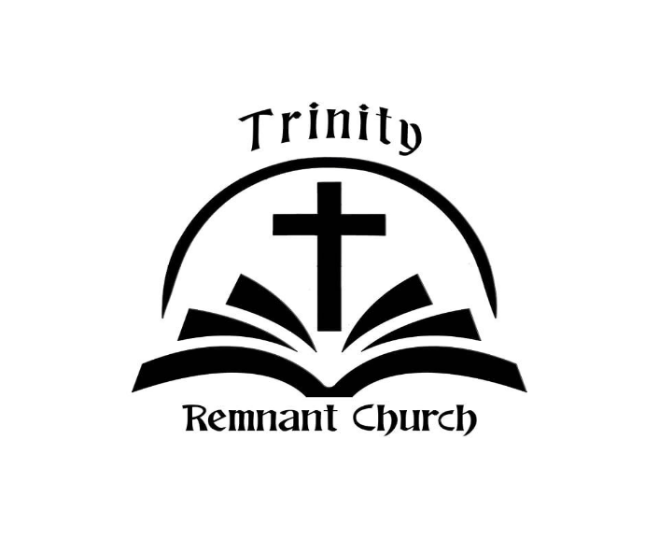

FEBRUARY 22, 2026

ROMANS 6:1-4

