May 03, 2026, Remnant Church 9:00 AM
* Call to Worship: (Hebrews 12:28-29)
* Prayer of Invocation
* Singing: Hymn 28 –, Crown Him With Many Crowns
*God’s Greeting:
The Disciple's Prayer (Lord's Prayer) – Page 120
The Reading of God's Law: Mark 12: 28-31
The General Confession
- Public (Unison)- Page 120
- Individual (Silently)
- Prayer (Minister)
* Singing: Hymn 26 – Come, We That Love The Lord
The Apostle's Creed (Unison) – Page 121
Congregational Prayer
- Individual and Pastoral
The Gloria Patri – Page 121
* Singing: Hymn 27 – Come, Ye Thankful People

Message: ROMANS 8:14-17, Sermon, and Prayer

* Singing: Hymn 29 – Facing A Task Unfinished
*Doxology: Page 121 - Praise God from whom all blessings flow
*Benediction
*if you are able, please stand
CALL TO WORSHIP: HEBREWS 12:28-29

²⁸ Therefore, since we are receiving a kingdom that cannot be shaken, let us be thankful, and so worship God acceptably with reverence and awe, ²⁹ for our “God is a consuming fire.”

READING OF THE LAW: MARK 12: 28-31

28 One of the teachers of the law came and heard them debating. Noticing that Jesus had given them a good answer, he asked Him, “Of all the commandments, which is the most important?”
29 “The most important one,” answered Jesus, “is this: ‘Hear, O Israel: The Lord our God, the Lord is one. 30 Love the Lord your God with all your heart and with all your soul and with all your mind and with all your strength.’ 31 The second is this: ‘Love your neighbor as yourself.’ There is no commandment greater than these.”

SERMON TEXT: ROMANS 8:14-17
14 For those who are led by the Spirit of God are the children of God. 15 The Spirit you received does not make you slaves, so that you live in fear again; rather, the Spirit you received brought about your adoption to sonship. And by him we cry, “Abba, Father.” 16 The Spirit himself testifies with our spirit that we are God’s children. 17 Now if we are children, then we are heirs—heirs of God and co-heirs with Christ, if indeed we share in his sufferings in order that we may also share in his glory.

CHURCH INFORMATION

Meeting Place: Pella Memorial Building
829 Broadway St Pella, IA 50219

Time: 9:00 AM

Phone: 641.858.6985

Email: pastor@trinityremnant.org

Parsonage Address: 535 Peoria Cross Street Pella, IA 50219

Website: www.trinityremnant.org

Our Commitment to God:

Doing ANYTHING for Him,
Going ANYWHERE for Him, and
Working ANYTIME for Him

Pastor: Benjamin Anum-Higher

TRINITY REMNANT CHURCH

PELLA, IA

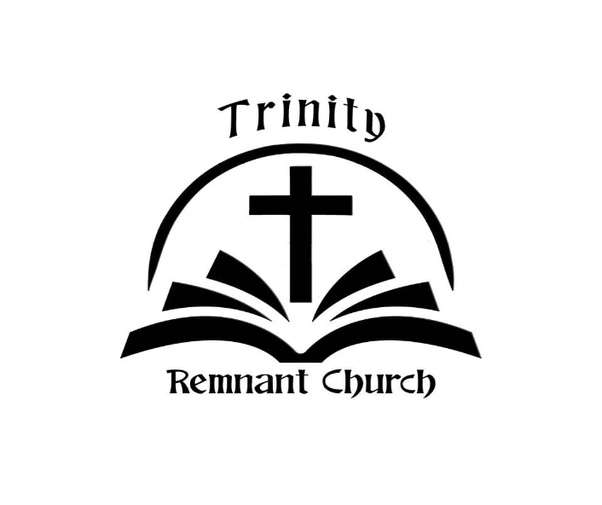

MAY 03, 2026

ROMANS 8:14-17

