March 29, 2026, Remnant Church 9:00 AM
* Call to Worship: (John 4:23-24)
* Prayer of Invocation
* Singing: Hymn 22 –Come, Christians, Join To Sing
*God’s Greeting:
The Disciple's Prayer (Lord's Prayer) – Page 120
The Reading of God's Law: Mark 12: 28-31
The General Confession
- Public (Unison)- Page 120
- Individual (Silently)
- Prayer (Minister)
* Singing: Hymn 33 –God, Be Merciful To Me
The Apostle's Creed (Unison) – Page 121
Congregational Prayer
- Individual and Pastoral
The Gloria Patri – Page 121
* Singing: Hymn 24 –Come, Thou Fount

Message: ROMANS 7:7-13, Sermon, and Prayer

* Singing: Hymn 25 – Come, Thou Long Expected Jesus
*Doxology: Page 121 - Praise God from whom all blessings flow
*Benediction
*if you are able, please stand
CALL TO WORSHIP: JOHN 4: 23-24

²³ Yet a time is coming and has now come when the true worshipers will worship the Father in the Spirit and in truth, for they are the kind of worshipers the Father seeks.
²⁴ God is spirit, and His worshipers must worship in the Spirit and in truth.”

SERMON TEXT: ROMANS 7:7 - 13

⁷ What shall we say, then? Is the law sinful? Certainly not! Nevertheless, I would not have known what sin was had it not been for the law. For I would not have known what coveting really was if the law had not said, “You shall not covet.” ⁸ But sin, seizing the opportunity afforded by the commandment, produced in me every kind of coveting. For apart from the law, sin was dead. ⁹ Once I was alive apart from the law; but when the commandment came, sin sprang to life and I died. ¹⁰ I found that the very commandment that was intended to bring life actually brought death. ¹¹ For sin, seizing the opportunity afforded by the commandment, deceived me, and through the commandment put me to death. ¹² So then, the law is holy, and the commandment is holy, righteous and good. ¹³ Did that which is good, then, become death to me? By no means! Nevertheless, in order that sin might be recognized as sin, it used what is good to bring about my death, so that through the commandment sin might become utterly sinful.

CHURCH INFORMATION

Meeting Place: Pella Memorial Building
829 Broadway St Pella, IA 50219

Time: 9:00 AM

Phone: 641.858.6985

Email: pastor@trinityremnant.org

Parsonage Address: 535 Peoria Cross Street Pella, IA 50219

Website: www.trinityremnant.org

Our Commitment to God:

Doing ANYTHING for Him,
Going ANYWHERE for Him, and
Working ANYTIME for Him

Pastor: Benjamin Anum-Higher

TRINITY REMNANT CHURCH

PELLA, IA

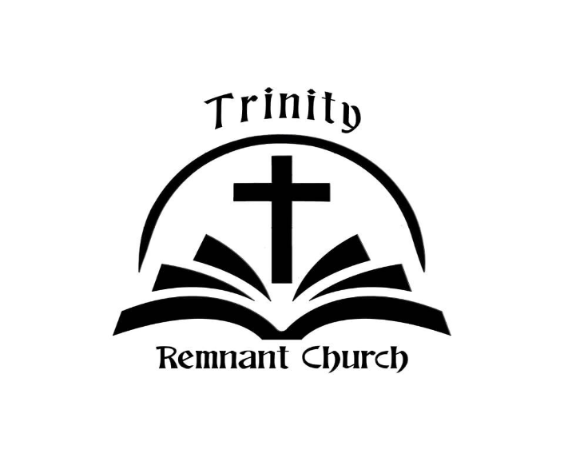

MARCH 29, 2026

ROMANS 7:7-13

