March 1, 2026, Remnant Church 9:00 AM
* Call to Worship: (Psalm 136: 1)
* Prayer of Invocation
* Singing: Hymn 89 –Praise the Lord! Ye Heavens
*God’s Greeting:
The Disciple's Prayer (Lord's Prayer) – Page 120
The Reading of God's Law: Mark 12: 28-31
The General Confession
- Public (Unison)- Page 120
- Individual (Silently)
- Prayer (Minister)
* Singing: Hymn 59 –Jesus Paid It All
The Apostle's Creed (Unison) – Page 121
Congregational Prayer
- Individual and Pastoral
The Gloria Patri – Page 121
* Singing: Hymn 61 –Jesus, the very thought of Thee

Message: ROMANS 6:5-14, Sermon, and Prayer

* Singing: Hymn 60 – Jesus Shall Reign
*Doxology: Page 121 - Praise God from whom all blessings flow
*Benediction
*if you are able, please stand
CALL TO WORSHIP: PSALM 136: 1

1 Give thanks to the Lord, for He is good, for His steadfast love endures forever.

SERMON TEXT: ROMANS 6:5- 14

5 For if we have been united with him in a death like His, we shall certainly be united with Him in a resurrection like His. 6 We know that our old self was crucified with Him in order that the body of sin might be brought to nothing, so that we would no longer be enslaved to sin. 7 For one who has died has been set free from sin. 8 Now if we have died with Christ, we believe that we will also live with Him.
9 We know that Christ, being raised from the dead, will never die again; death no longer has dominion over Him. 10 For the death He died He died to sin, once for all, but the life He lives He lives to God. 11 So you also must consider yourselves dead to sin and alive to God in Christ Jesus.
12 Let not sin therefore reign in your mortal body, to make you obey its passions. 13 Do not present your members to sin as instruments for unrighteousness, but present yourselves to God as those who have been brought from death to life, and your members to God as instruments for righteousness. 14 For sin will have no dominion over you, since you are not under law but under grace.

CHURCH INFORMATION

Meeting Place: Pella Memorial Building
829 Broadway St Pella, IA 50219

Time: 9:00 AM

Phone: 641.858.6985

Email: pastor@trinityremnant.org

Parsonage Address: 535 Peoria Cross Street Pella, IA 50219

Website: www.trinityremnant.org

Our Commitment to God:

Doing ANYTHING for Him,
Going ANYWHERE for Him, and
Working ANYTIME for Him

Pastor: Benjamin Anum-Higher

TRINITY REMNANT CHURCH

PELLA, IA

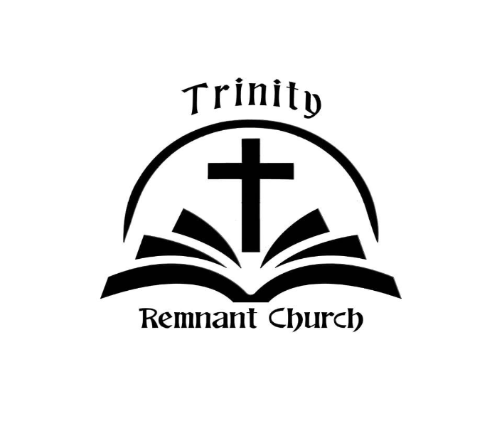

March 1, 2026

ROMANS 6:5-14

