March 8, 2026, Remnant Church 9:00 AM
* Call to Worship: (Psalm 136: 1)
* Prayer of Invocation
* Singing: Hymn 89 –Praise the Lord! Ye Heavens
*God’s Greeting:
The Disciple's Prayer (Lord's Prayer) – Page 120
The Reading of God's Law: Mark 12: 28-31
The General Confession
- Public (Unison)- Page 120
- Individual (Silently)
- Prayer (Minister)
* Singing: Hymn 59 –Jesus Paid It All
The Apostle's Creed (Unison) – Page 121
Congregational Prayer
- Individual and Pastoral
The Gloria Patri – Page 121
* Singing: Hymn 61 –Jesus, the very thought of Thee

Message: ROMANS 6:15-23, Sermon, and Prayer

* Singing: Hymn 60 – Jesus Shall Reign
*Doxology: Page 121 - Praise God from whom all blessings flow
*Benediction
*if you are able, please stand
CALL TO WORSHIP: PSALM 136: 1

1 Give thanks to the Lord, for He is good, for His steadfast love endures forever.

SERMON TEXT: ROMANS 6:15- 23

15 What then? Are we to sin because we are not under law but under grace? By no means! 16 Do you not know that if you present yourselves to anyone as obedient slaves, you are slaves of the one whom you obey, either of sin, which leads to death, or of obedience, which leads to righteousness? 17 But thanks be to God, that you who were once slaves of sin have become obedient from the heart to the standard of teaching to which you were committed, 18 and, having been set free from sin, have become slaves of righteousness. 19 I am speaking in human terms, because of your natural limitations. For just as you once presented your members as slaves to impurity and to lawlessness leading to more lawlessness, so now present your members as slaves to righteousness leading to sanctification.

20 For when you were slaves of sin, you were free in regard to righteousness. 21 But what fruit were you getting at that time from the things of which you are now ashamed? For the end of those things is death. 22 But now that you have been set free from sin and have become slaves of God, the fruit you get leads to sanctification and its end, eternal life. 23 For the wages of sin is death, but the free gift of God is eternal life in Christ Jesus our Lord.

CHURCH INFORMATION

Meeting Place: Pella Memorial Building
829 Broadway St Pella, IA 50219

Time: 9:00 AM

Phone: 641.858.6985

Email: pastor@trinityremnant.org

Parsonage Address: 535 Peoria Cross Street Pella, IA 50219

Website: www.trinityremnant.org

Our Commitment to God:

Doing ANYTHING for Him,
Going ANYWHERE for Him, and
Working ANYTIME for Him

Pastor: Benjamin Anum-Higher

TRINITY REMNANT CHURCH

PELLA, IA

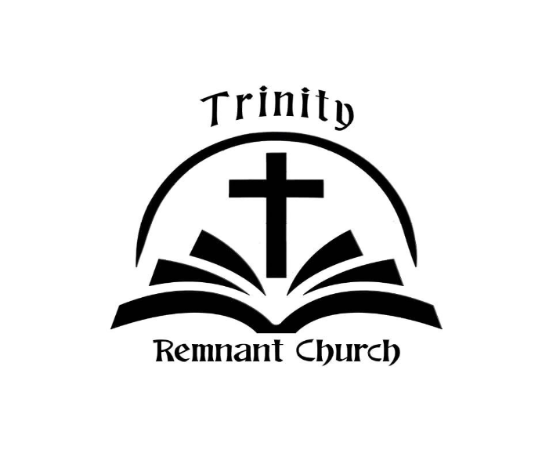

March 8, 2026

ROMANS 6:15-23

