July 5, 2026, Remnant Church 9:00 AM
* Call to Worship: (John 4:23-24)
* Prayer of Invocation
* Singing: Hymn 62 – Jesus, Thou Joy Of Loving Hearts
*God’s Greeting:
The Disciple's Prayer (Lord's Prayer) – Page 120
The Reading of God's Law: Mark 12: 28-31
The General Confession
- Public (Unison)- Page 120
- Individual (Silently)
- Prayer (Minister)
* Singing: Hymn 64 – Join All The Glorious Names
The Apostle's Creed (Unison) – Page 121
Congregational Prayer
- Individual and Pastoral
The Gloria Patri – Page 121
* Singing: Hymn 63 – Jesus, Thy Blood

Message: ROMANS 8:33-34, Sermon, and Prayer

* Singing: Hymn 65 – Joy To The World
*Doxology: Page 121 - Praise God from whom all blessings flow
*Benediction
*if you are able, please stand
CALL TO WORSHIP: JOHN 4:23-24

²³ Yet a time is coming and has now come when the true worshipers will worship the Father in the Spirit and in truth, for they are the kind of worshipers the Father seeks. ²⁴ God is spirit, and his worshipers must worship in the Spirit and in truth.”

READING OF THE LAW: MARK 12: 28-31

28 One of the teachers of the law came and heard them debating. Noticing that Jesus had given them a good answer, he asked Him, “Of all the commandments, which is the most important?”
29 “The most important one,” answered Jesus, “is this: ‘Hear, O Israel: The Lord our God, the Lord is one. 30 Love the Lord your God with all your heart and with all your soul and with all your mind and with all your strength.’ 31 The second is this: ‘Love your neighbor as yourself.’ There is no commandment greater than these.”

SERMON TEXT: ROMANS 8:33-34
33 Who will bring any charge against those whom God has chosen? It is God who justifies. 34 Who then is the one who condemns? No one. Christ Jesus who died—more than that, who was raised to life—is at the right hand of God and is also interceding for us.

CHURCH INFORMATION

Meeting Place: Pella Memorial Building
829 Broadway St Pella, IA 50219

Time: 9:00 AM

Phone: 641.858.6985

Email: pastor@trinityremnant.org

Parsonage Address: 535 Peoria Cross Street Pella, IA 50219

Website: www.trinityremnant.org

Our Commitment to God:

Doing ANYTHING for Him,
Going ANYWHERE for Him, and
Working ANYTIME for Him

Pastor: Benjamin Anum-Higher

TRINITY REMNANT CHURCH

PELLA, IA

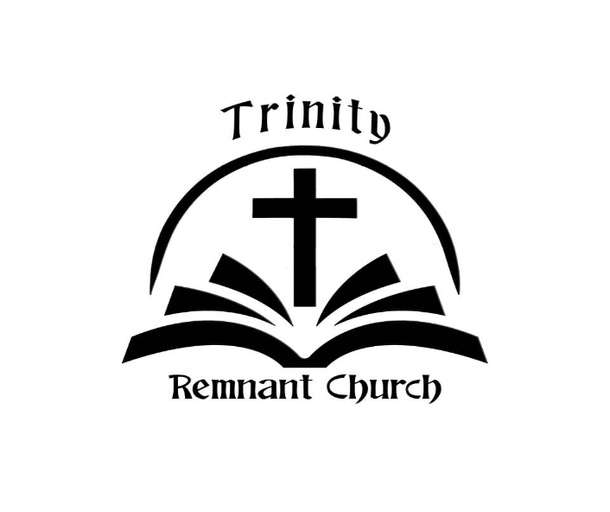

JULY 5, 2026

ROMANS 8:33-34

