October 11, 2026, Remnant Church 9:00 AM
* Call to Worship: (Psalm 115:1)
* Prayer of Invocation
* Singing: Hymn 10 – Angels From The Realms Of Glory
*God’s Greeting:
The Disciple's Prayer (Lord's Prayer) – Page 120
The Reading of God's Law: Exodus 20
The General Confession
- Public (Unison)- Page 120
- Individual (Silently)
- Prayer (Minister)
* Singing: Hymn 8 – Amazing Grace!
The Apostle's Creed (Unison) – Page 121
Congregational Prayer
- Individual and Pastoral
* The Gloria Patri – Page 121
* Singing: Hymn 11 – Angels We Have Heard On High

Message: ROMANS 9:22-24, Sermon, and Prayer

* Singing: Hymn 9 – And Can It Be That I Should Gain
*Doxology: Page 121 – Praise God From Whom All Blessings Flow.
*Benediction
*if you are able, please stand
CALL TO WORSHIP: PSALM 115:1

Not to us, Lord, not to us but to Your name be the glory, because of Your love and faithfulness.

READING OF THE LAW: EXODUS 20

God spoke all these words

1.You shall have no other gods before Me.
2. You shall not make for yourself an idol. You shall not bow down to them or worship them.
3. You shall not make wrongful use of the name of the Lord your God.
4. Remember the Sabbath day and keep it holy.
5. Honor your father and your mother.
6. You shall not murder.
7. You shall not commit adultery.
8. You shall not steal.
9. You shall not bear false witness against your neighbor.
10. You shall not covet your neighbor’s house; you shall not covet your neighbor’s wife, or male or female servant, or ox, or donkey, or anything that belongs to your neighbor.

SERMON TEXT: ROMANS 9:22-24
22 What if God, although choosing to show His wrath and make His power known, bore with great patience the objects of His wrath—prepared for destruction? 23 What if He did this to make the riches of His glory known to the objects of His mercy, whom He prepared in advance for glory— 24 even us, whom He also called, not only from the Jews but also from the Gentiles?

CHURCH INFORMATION

Meeting Place: Pella Memorial Building
829 Broadway St Pella, IA 50219

Time: 9:00 AM

Phone: 641.858.6985

Email: pastor@trinityremnant.org

Parsonage Address: 535 Peoria Cross Street Pella, IA 50219

Website: www.trinityremnant.org

Our Commitment to God:

Doing ANYTHING for Him,
Going ANYWHERE for Him, and
Working ANYTIME for Him

Pastor: Benjamin Anum-Higher

TRINITY REMNANT CHURCH

PELLA, IA

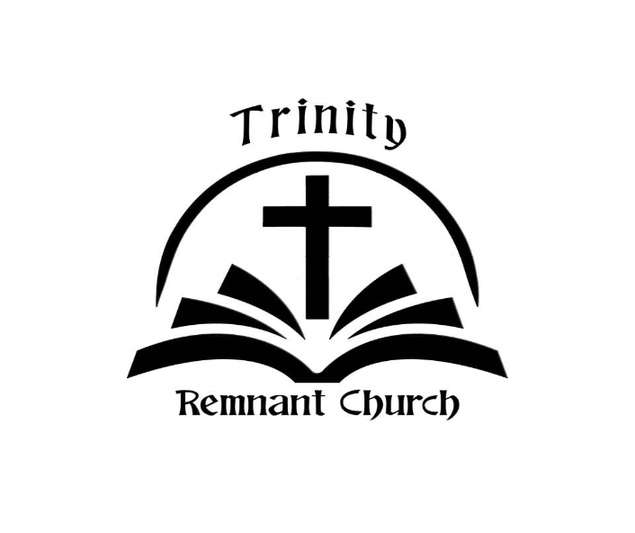

OCTOBER 11, 2026

ROMANS 9:22-24

