February 15, 2026, Remnant Church 9:00 AM
* Call to Worship: (Psalm 136: 1)
* Prayer of Invocation
* Singing: Hymn 89 –Praise the Lord! Ye Heavens
*God’s Greeting:
The Disciple's Prayer (Lord's Prayer) – Page 120
The Reading of God's Law: Mark 12: 28-31
The General Confession
- Public (Unison)- Page 120
- Individual (Silently)
- Prayer (Minister)
* Singing: Hymn 59 –Jesus Paid It All
The Apostle's Creed (Unison) – Page 121
Congregational Prayer
- Individual and Pastoral
The Gloria Patri – Page 121
* Singing: Hymn 61 –Jesus, the very thought of Thee

Message: ROMANS 5:12-19, Sermon, and Prayer

* Singing: Hymn 60 – Jesus Shall Reign
*Doxology: Page 121 - Praise God from whom all blessings flow
*Benediction
*if you are able, please stand
CALL TO WORSHIP: PSALM 136: 1

1 Give thanks to the Lord, for He is good, for His steadfast love endures forever.

SERMON TEXT: ROMANS 5:12- 19

12 Therefore, just as sin entered the world through one man, and death through sin, and in this way death came to all people, because all sinned— 13 To be sure, sin was in the world before the law was given, but sin is not charged against anyone’s account where there is no law. 14 Nevertheless, death reigned from the time of Adam to the time of Moses, even over those who did not sin by breaking a command, as did Adam, who is a pattern of the one to come. 15 But the gift is not like the trespass. For if the many died by the trespass of the one man, how much more did God’s grace and the gift that came by the grace of the one man, Jesus Christ, overflow to the many! 16 Nor can the gift of God be compared with the result of one man’s sin: The judgment followed one sin and brought condemnation, but the gift followed many trespasses and brought justification. 17 For if, by the trespass of the one man, death reigned through that one man, how much more will those who receive God’s abundant provision of grace and of the gift of righteousness reign in life through the one man, Jesus Christ!

18 Consequently, just as one trespass resulted in condemnation for all people, so also one righteous act resulted in justification and life for all people. 19 For just as through the disobedience of the one man the many were made sinners, so also through the obedience of the one man the many will be made righteous.

CHURCH INFORMATION

Meeting Place: Pella Memorial Building
829 Broadway St Pella, IA 50219

Time: 9:00 AM

Phone: 641.858.6985

Email: pastor@trinityremnant.org

Parsonage Address: 535 Peoria Cross Street Pella, IA 50219

Website: www.trinityremnant.org

Our Commitment to God:

Doing ANYTHING for Him,
Going ANYWHERE for Him, and
Working ANYTIME for Him

Pastor: Benjamin Anum-Higher

TRINITY REMNANT CHURCH

PELLA, IA

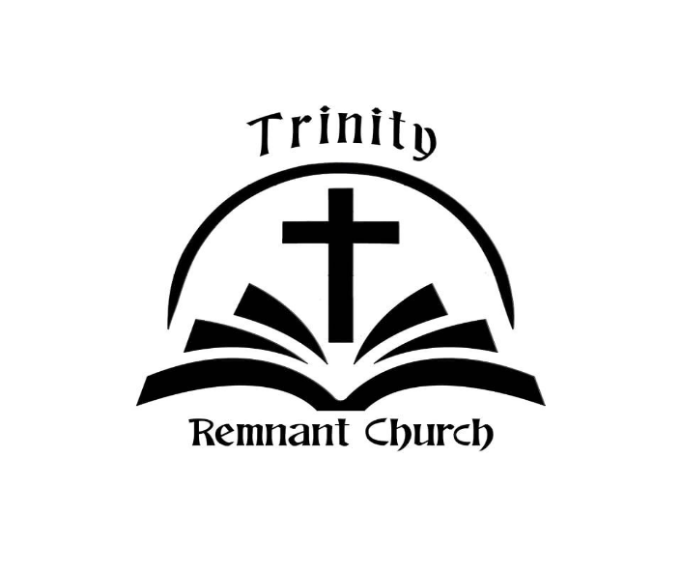

FEBRUARY 15, 2026

ROMANS 5:12-19

