May 17, 2026, Remnant Church 9:00 AM
* Call to Worship: (John 15:4-5, 9-10)
* Prayer of Invocation
* Singing: Hymn 36 – Great is Thy faithfulness
*God’s Greeting:
The Disciple's Prayer (Lord's Prayer) – Page 120
The Reading of God's Law: Mark 12: 28-31
The General Confession
- Public (Unison)- Page 120
- Individual (Silently)
- Prayer (Minister)
* Singing: Hymn 37 – Guide Me, O Thou Great Jehovah
The Apostle's Creed (Unison) – Page 121
Congregational Prayer
- Individual and Pastoral
The Gloria Patri – Page 121
* Singing: Hymn 35 – God Leads Us Along

Message: ROMANS 8:18, Sermon, and Prayer

* Singing: Hymn 34 – God Is Our Refuge
*Doxology: Page 121 - Praise God from whom all blessings flow
*Benediction
*if you are able, please stand
CALL TO WORSHIP: JOHN 15:4-5, 9-10

4 Remain in Me, as I also remain in you. No branch can bear fruit by itself; it must remain in the vine. Neither can you bear fruit unless you remain in Me. 5 “I am the vine; you are the branches. If you remain in Me and I in you, you will bear much fruit; apart from Me you can do nothing.
9 “As the Father has loved Me, so have I loved you. Now remain in My love. 10 If you keep My commands, you will remain in My love, just as I have kept My Father’s commands and remain in His love.

READING OF THE LAW: MARK 12: 28-31

28 One of the teachers of the law came and heard them debating. Noticing that Jesus had given them a good answer, he asked Him, “Of all the commandments, which is the most important?”
29 “The most important one,” answered Jesus, “is this: ‘Hear, O Israel: The Lord our God, the Lord is one. 30 Love the Lord your God with all your heart and with all your soul and with all your mind and with all your strength.’ 31 The second is this: ‘Love your neighbor as yourself.’ There is no commandment greater than these.”

SERMON TEXT: ROMANS 8:18
18 I consider that our present sufferings are not worth comparing with the glory that will be revealed in us.

CHURCH INFORMATION

Meeting Place: Pella Memorial Building
829 Broadway St Pella, IA 50219

Time: 9:00 AM

Phone: 641.858.6985

Email: pastor@trinityremnant.org

Parsonage Address: 535 Peoria Cross Street Pella, IA 50219

Website: www.trinityremnant.org

Our Commitment to God:

Doing ANYTHING for Him,
Going ANYWHERE for Him, and
Working ANYTIME for Him

Pastor: Benjamin Anum-Higher

TRINITY REMNANT CHURCH

PELLA, IA

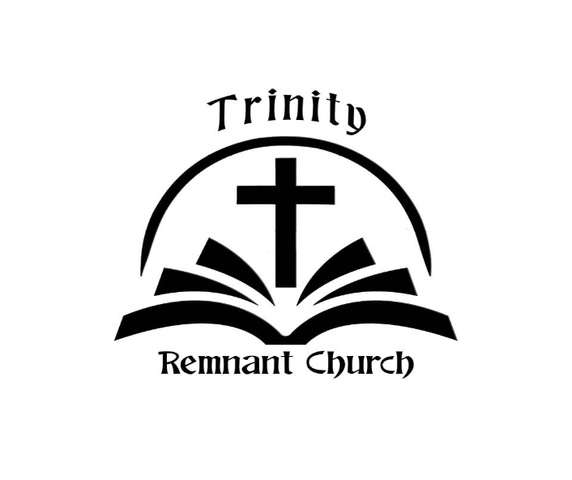

MAY 17, 2026

ROMANS 8:18

