November 30, 2025 Remnant Church 9:00 AM
* Call to Worship: (Psalm 1: 1, 5-8)
* Prayer of Invocation
* Singing: Hymn 36 – Great Is Thy Faithfulness
*God’s Greeting:
The Disciple's Prayer (Lord's Prayer) – Page 120
The Reading of God's Law: Deuteronomy 5:1-22
The General Confession
- Public (Unison)- Page 120
- Individual (Silently)
- Prayer (Minister)
* Singing: Hymn 99 – Take My Life And Let It Be
The Apostle's Creed (Unison) – Page 121
Congregational Prayer
- Individual and Pastoral
The Gloria Patri – Page 121
* Singing: Hymn 69 – Love Divine, All Loves Excelling

Message: ROMANS 3:1-2, Sermon, and Prayer

* Singing: Hymn 94 – Rock of Ages
*Doxology: Page 121 - Praise God from whom all blessings flow
*Benediction
*if you are able, please stand
CALL TO WORSHIP: PSALM 1: 1, 5-8

1 I will sing of the Lord’s great love forever; with my mouth I will make Your faithfulness known through all generations.

5 The heavens praise Your wonders, Lord, Your faithfulness too, in the assembly of the holy ones.
6 For who in the skies above can compare with the Lord? Who is like the Lord among the heavenly beings?
7 In the council of the holy ones God is greatly feared; He is more awesome than all who surround Him.
8 Who is like You, Lord God Almighty? You, Lord, are mighty, and Your faithfulness surrounds You.

SERMON TEXT: ROMANS 3: 1-2

1 What advantage, then, is there in being a Jew, or what value is there in circumcision?

2 Much in every way! First of all, the Jews have been entrusted with the very words of God.

CHURCH INFORMATION

Meeting Place: Pella Memorial Building
829 Broadway St Pella, IA 50219

Time: 9:00 AM

Phone: 641.858.6985

Email: pastor@trinityremnant.org

Parsonage Address: 535 Peoria Cross Street Pella, IA 50219

Website: www.trinityremnant.org

Our Commitment to God:

Doing ANYTHING for Him,
Going ANYWHERE for Him, and
Working ANYTIME for Him

Pastor: Benjamin Anum-Higher

TRINITY REMNANT CHURCH

PELLA, IA

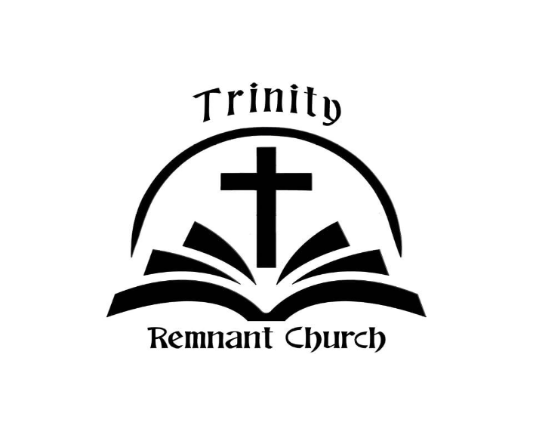

NOVEMBER 30, 2025

ROMANS 3:1-2

