September 13, 2026, Remnant Church 9:00 AM
* Call to Worship: (Psalm 22:23-24)
* Prayer of Invocation
* Singing: Hymn 107 – To God Be The Glory
*God’s Greeting:
The Disciple's Prayer (Lord's Prayer) – Page 120
The Reading of God's Law: Exodus 20
The General Confession
- Public (Unison)- Page 120
- Individual (Silently)
- Prayer (Minister)
* Singing: Hymn 108 – We Come, O Christ, To You
The Apostle's Creed (Unison) – Page 121
Congregational Prayer
- Individual and Pastoral
* The Gloria Patri – Page 121
* Singing: Hymn 106 – Through All

Message: ROMANS 9:13, Sermon, and Prayer

* Singing: Hymn 105 – This Is My Father's World
*Doxology: Page 121 - Praise God From Whom All Blessings Flow.
*Benediction
*if you are able, please stand
CALL TO WORSHIP: PSALM 22:23-24

23 You who fear the Lord, praise Him! All you descendants of Jacob, honor Him! Revere Him, all you descendants of Israel!
24 For He has not despised or scorned the suffering of the afflicted one; He has not hidden His face from him but has listened to his cry for help.

READING OF THE LAW: EXODUS 20

God spoke all these words

1.You shall have no other gods before Me.
2. You shall not make for yourself an idol. You shall not bow down to them or worship them.
3. You shall not make wrongful use of the name of the Lord your God.
4. Remember the Sabbath day and keep it holy.
5. Honor your father and your mother.
6. You shall not murder.
7. You shall not commit adultery.
8. You shall not steal.
9. You shall not bear false witness against your neighbor.
10. You shall not covet your neighbor’s house; you shall not covet your neighbor’s wife, or male or female servant, or ox, or donkey, or anything that belongs to your neighbor.

SERMON TEXT: ROMANS 9:13
13 Just as it is written: “Jacob I loved, but Esau I hated.”

CHURCH INFORMATION

Meeting Place: Pella Memorial Building
829 Broadway St Pella, IA 50219

Time: 9:00 AM

Phone: 641.858.6985

Email: pastor@trinityremnant.org

Parsonage Address: 535 Peoria Cross Street Pella, IA 50219

Website: www.trinityremnant.org

Our Commitment to God:

Doing ANYTHING for Him,
Going ANYWHERE for Him, and
Working ANYTIME for Him

Pastor: Benjamin Anum-Higher

TRINITY REMNANT CHURCH

PELLA, IA

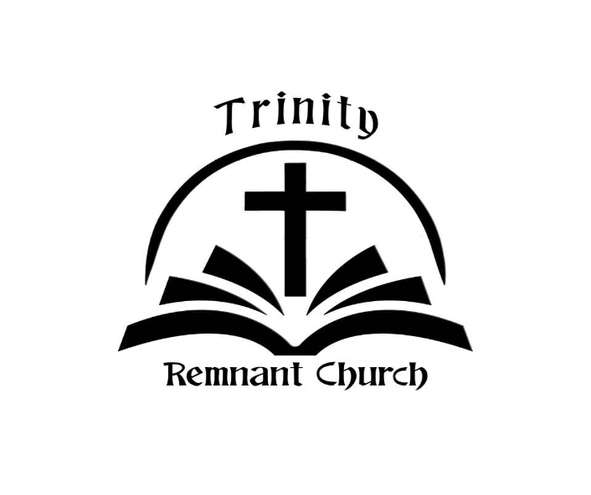

SEPTEMBER 13, 2026

ROMANS 9:13

