August 30, 2026, Remnant Church 9:00 AM
* Call to Worship: (Revelation 4:11)
* Prayer of Invocation
* Singing: Hymn 98 – Stand Up, Stand Up For Jesus
*God’s Greeting:
The Disciple's Prayer (Lord's Prayer) – Page 120
The Reading of God's Law: Mark 12: 28-31
The General Confession
- Public (Unison)- Page 120
- Individual (Silently)
- Prayer (Minister)
* Singing: Hymn 99 – Take My Life And Let It Be
The Apostle's Creed (Unison) – Page 121
Congregational Prayer
- Individual and Pastoral
* The Gloria Patri – Page 121
* Singing: Hymn 97 – Sovereign Ruler Of The Skies

Message: ROMANS 9:6-13, Sermon, and Prayer (PT 1)

* Singing: Hymn 100 – Teach Me Thy Way, O Lord
*Doxology: Page 121 - Praise God From Whom All Blessings Flow.
*Benediction
*if you are able, please stand
CALL TO WORSHIP: REVELATION 4:11

“You are worthy, our Lord and God, to receive glory and honor and power, for You created all things, and by Your will they were created and have their being.”

READING OF THE LAW: MARK 12: 28-31

28 One of the teachers of the law came and heard them debating. Noticing that Jesus had given them a good answer, he asked Him, “Of all the commandments, which is the most important?”
29 “The most important one,” answered Jesus, “is this: ‘Hear, O Israel: The Lord our God, the Lord is one. 30 Love the Lord your God with all your heart and with all your soul and with all your mind and with all your strength.’ 31 The second is this: ‘Love your neighbor as yourself.’ There is no commandment greater than these.”

SERMON TEXT: ROMANS 9:6-13 (First Part)
6 It is not as though God’s word had failed. For not all who are descended from Israel are Israel. 7 Nor because they are his descendants are they all Abraham’s children. On the contrary, “It is through Isaac that your offspring will be reckoned.” 8 In other words, it is not the children by physical descent who are God’s children, but it is the children of the promise who are regarded as Abraham’s offspring. 9 For this was how the promise was stated: “At the appointed time I will return, and Sarah will have a son.” 10 Not only that, but Rebekah’s children were conceived at the same time by our father Isaac. 11 Yet, before the twins were born or had done anything good or bad—in order that God’s purpose in election might stand: 12 not by works but by him who calls—she was told, “The older will serve the younger.” 13 Just as it is written: “Jacob I loved, but Esau I hated.”

CHURCH INFORMATION

Meeting Place: Pella Memorial Building
829 Broadway St Pella, IA 50219

Time: 9:00 AM

Phone: 641.858.6985

Email: pastor@trinityremnant.org

Parsonage Address: 535 Peoria Cross Street Pella, IA 50219

Website: www.trinityremnant.org

Our Commitment to God:

Doing ANYTHING for Him,
Going ANYWHERE for Him, and
Working ANYTIME for Him

Pastor: Benjamin Anum-Higher

TRINITY REMNANT CHURCH

PELLA, IA

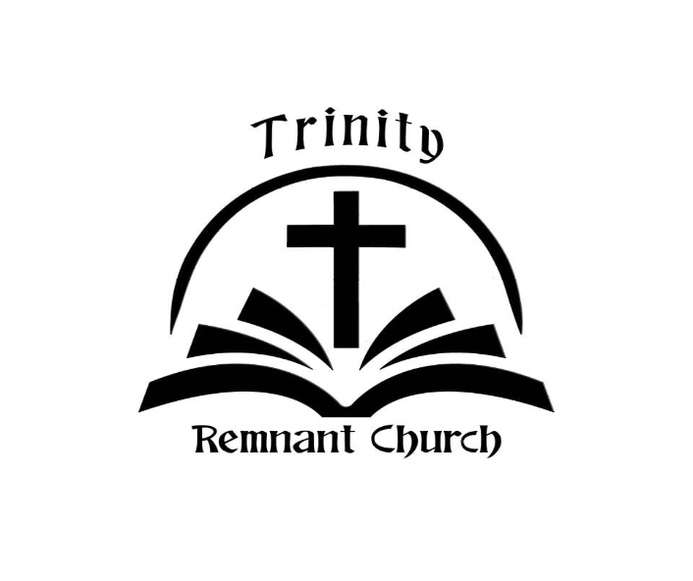

AUGUST 30, 2026

ROMANS 9:6-13 (1st)

