October 18, 2026, Remnant Church 9:00 AM
* Call to Worship: (Psalm 95:1-2)
* Prayer of Invocation
* Singing: Hymn 15 – Begin, My Tongue
*God’s Greeting:
The Disciple's Prayer (Lord's Prayer) – Page 120
The Reading of God's Law: Exodus 20
The General Confession
- Public (Unison)- Page 120
- Individual (Silently)
- Prayer (Minister)
* Singing: Hymn 14 – Before The Throne of God Above
The Apostle's Creed (Unison) – Page 121
Congregational Prayer
- Individual and Pastoral
* The Gloria Patri – Page 121
* Singing: Hymn 12 – Be Still, My Soul!

Message: ROMANS 9:25-26, Sermon, and Prayer

* Singing: Hymn 13 – Be Thou My Vision
*Doxology: Page 121 – Praise God From Whom All Blessings Flow.
*Benediction
*if you are able, please stand
CALL TO WORSHIP: PSALM 95:1-2

1 Come, let us sing for joy to the Lord; let us shout aloud to the Rock of our salvation. 2 Let us come before Him with thanksgiving and extol Him with music and song.

READING OF THE LAW: EXODUS 20

God spoke all these words

1.You shall have no other gods before Me.
2. You shall not make for yourself an idol. You shall not bow down to them or worship them.
3. You shall not make wrongful use of the name of the Lord your God.
4. Remember the Sabbath day and keep it holy.
5. Honor your father and your mother.
6. You shall not murder.
7. You shall not commit adultery.
8. You shall not steal.
9. You shall not bear false witness against your neighbor.
10. You shall not covet your neighbor’s house; you shall not covet your neighbor’s wife, or male or female servant, or ox, or donkey, or anything that belongs to your neighbor.

SERMON TEXT: ROMANS 9:25-26
25 As he says in Hosea: “I will call them ‘my people’ who are not my people; and I will call her ‘my loved one’ who is not my loved one,” 26 and, “In the very place where it was said to them, ‘You are not my people,’ there they will be called ‘children of the living God.’”

CHURCH INFORMATION

Meeting Place: Pella Memorial Building
829 Broadway St Pella, IA 50219

Time: 9:00 AM

Phone: 641.858.6985

Email: pastor@trinityremnant.org

Parsonage Address: 535 Peoria Cross Street Pella, IA 50219

Website: www.trinityremnant.org

Our Commitment to God:

Doing ANYTHING for Him,
Going ANYWHERE for Him, and
Working ANYTIME for Him

Pastor: Benjamin Anum-Higher

TRINITY REMNANT CHURCH

PELLA, IA

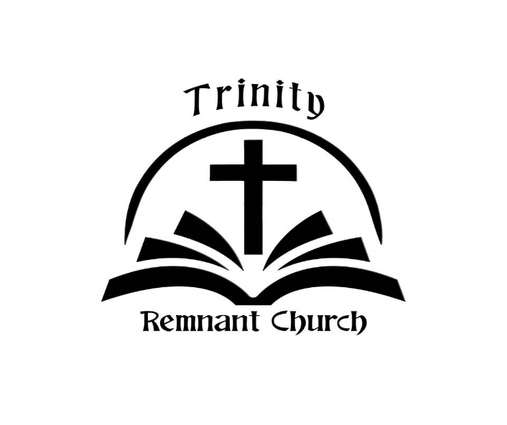

OCTOBER 18, 2026

ROMANS 9:25-26

