September 14, 2025 Remnant Church 9:00 AM
* Call to Worship: (Psalm 22:27-28)
* Prayer of Invocation
* Singing: Song of Praise: Come, Christians, join to sing
*God’s Greeting:
The Disciple's Prayer (Lord's Prayer) in Unison
The Reading of God's Law: Deuteronomy 30: 15-20
The General Confession
- Public (Unison)
- Individual (Silently)
- Prayer (Minister)
* Singing: Song of Confession: A Debtor To Mercy Alone
The Apostle's Creed (Unison)
Congregational Prayer
- Individual and Pastoral
The Gloria Patri
* Singing: Song of Preparation: All the way my Savior leads me.
Message: ROMANS 1:1, Sermon, and Prayer
* Singing: Song of Dedication: Alas! and did my Savior bleed
*Doxology: Praise God from whom all blessings flow
*Benediction
*if you are able, please stand
Call to Worship: (Psalm 22:27-28)

27 All the ends of the earth will remember and turn to the Lord, and all the families of the nations will bow down before him, 28 for dominion belongs to the Lord and he rules over the nations.
The Reading of God's Law: Deuteronomy 30: 15-20

15 See, I set before you today life and prosperity, death and destruction. 16 For I command you today to love the Lord your God, to walk in obedience to him, and to keep his commands, decrees and laws; then you will live and increase, and the Lord your God will bless you in the land you are entering to possess.
17 But if your heart turns away and you are not obedient, and if you are drawn away to bow down to other gods and worship them, 18 I declare to you this day that you will certainly be destroyed. You will not live long in the land you are crossing the Jordan to enter and possess.
19 This day I call the heavens and the earth as witnesses against you that I have set before you life and death, blessings and curses. Now choose life, so that you and your children may live 20 and that you may love the Lord your God, listen to his voice, and hold fast to him. For the Lord is your life, and he will give you many years in the land he swore to give to your fathers, Abraham, Isaac and Jacob.

SERMON TEXT: ROMANS 1: 1

1 Paul, a servant of Christ Jesus, called to be an apostle and set apart for the gospel of God

CHURCH INFORMATION

Meeting Place: Pella Memorial Building
829 Broadway St Pella, IA 50219

Time: 9:00 AM

Phone: 641.858.6985

Email: pastor@trinityremnant.org

Parsonage Address: 535 Peoria Cross Street Pella, IA 50219

Website: www.trinityremnant.org

Our Commitment to God:

Doing ANYTHING for Him,
Going ANYWHERE for Him, and
Working ANYTIME for Him

Pastor: Benjamin Anum-Higher

TRINITY REMNANT CHURCH

PELLA, IA

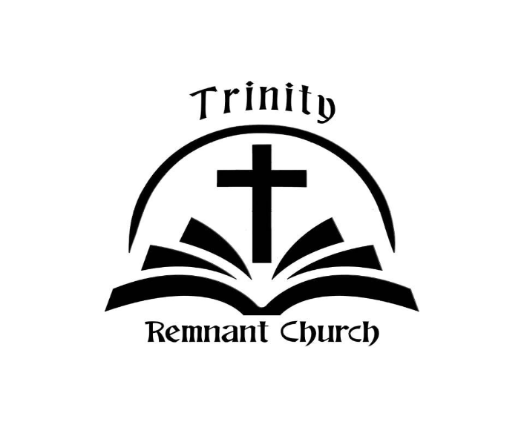

SEPTEMBER 14, 2025

ROMANS 1:1

