December 14, 2025 Remnant Church 9:00 AM
* Call to Worship: (Psalm 150: 1-2)
* Prayer of Invocation
* Singing: Hymn 36 – Great Is Thy Faithfulness
*God’s Greeting:
The Disciple's Prayer (Lord's Prayer) – Page 120
The Reading of God's Law: Exodus 20
The General Confession
- Public (Unison)- Page 120
- Individual (Silently)
- Prayer (Minister)
* Singing: Hymn 69 – Love Divine, All Loves Excelling
The Apostle's Creed (Unison) – Page 121
Congregational Prayer
- Individual and Pastoral
The Gloria Patri – Page 121
* Singing: Hymn 99 – Take My Life And Let It Be

Message: ROMANS 3:9-18, Sermon, and Prayer

* Singing: Hymn 94 – Rock of Ages
*Doxology: Page 121 - Praise God from whom all blessings flow
*Benediction
*if you are able, please stand
CALL TO WORSHIP: PSALM 150: 1-2

1 Praise the Lord. Praise God in His sanctuary;
praise Him in His mighty heavens.
2 Praise Him for His acts of power;
praise Him for His surpassing greatness.

SERMON TEXT: ROMANS 3: 9-18

9 What shall we conclude then? Do we have any advantage? Not at all! For we have already made the charge that Jews and Gentiles alike are all under the power of sin.
10 As it is written: “There is no one righteous, not even one; 11 there is no one who understands; there is no one who seeks God. 12 All have turned away, they have together become worthless; there is no one who does good, not even one.”
13 “Their throats are open graves; their tongues practice deceit.” “The poison of vipers is on their lips.” 14 “Their mouths are full of cursing and bitterness.”
15 “Their feet are swift to shed blood; 16 ruin and misery mark their ways, 17 and the way of peace they do not know.”
18 “There is no fear of God before their eyes.

CHURCH INFORMATION

Meeting Place: Pella Memorial Building
829 Broadway St Pella, IA 50219

Time: 9:00 AM

Phone: 641.858.6985

Email: pastor@trinityremnant.org

Parsonage Address: 535 Peoria Cross Street Pella, IA 50219

Website: www.trinityremnant.org

Our Commitment to God:

Doing ANYTHING for Him,
Going ANYWHERE for Him, and
Working ANYTIME for Him

Pastor: Benjamin Anum-Higher

TRINITY REMNANT CHURCH

PELLA, IA

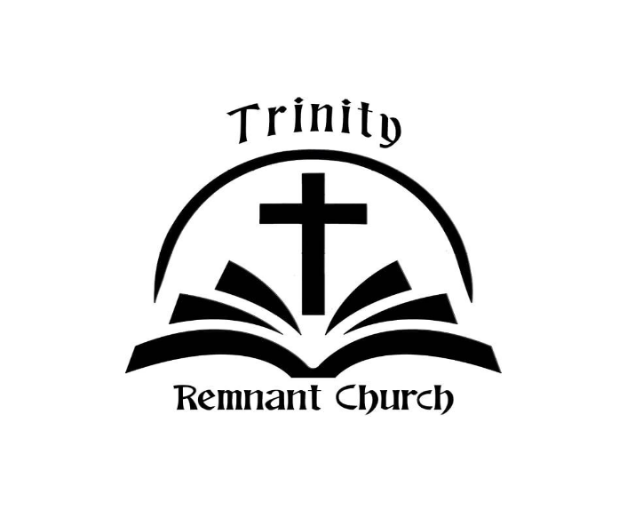

DECEMBER 14, 2025

ROMANS 3:9-18

