February 8, 2026, Remnant Church 9:00 AM
* Call to Worship: (Psalm 150: 1-2)
* Prayer of Invocation
* Singing: Hymn 89 –Praise the Lord! Ye Heavens
*God’s Greeting:
The Disciple's Prayer (Lord's Prayer) – Page 120
The Reading of God's Law: Mark 12: 28-31
The General Confession
- Public (Unison)- Page 120
- Individual (Silently)
- Prayer (Minister)
* Singing: Hymn 67 –Just as I am, without one plea
The Apostle's Creed (Unison) – Page 121
Congregational Prayer
- Individual and Pastoral
The Gloria Patri – Page 121
* Singing: Hymn 61 –Jesus, the very thought of Thee

Message: ROMANS 5:6-11, Sermon, and Prayer

* Singing: Hymn 92 – Rejoice, the Lord is King
*Doxology: Page 121 - Praise God from whom all blessings flow
*Benediction
*if you are able, please stand
CALL TO WORSHIP: PSALM 150: 1-2

1 Praise the Lord. Praise God in His sanctuary; praise Him in His mighty heavens. 2 Praise Him for His acts of power; praise Him for His surpassing greatness.

READING OF THE LAW: MARK 12: 28-31

28 One of the teachers of the law came and heard them debating. Noticing that Jesus had given them a good answer, he asked Him, “Of all the commandments, which is the most important?”
29 “The most important one,” answered Jesus, “is this: ‘Hear, O Israel: The Lord our God, the Lord is one. 30 Love the Lord your God with all your heart and with all your soul and with all your mind and with all your strength.’ 31 The second is this: ‘Love your neighbor as yourself.’ There is no commandment greater than these.”

SERMON TEXT: ROMANS 5:6- 11

6 You see, at just the right time, when we were still powerless, Christ died for the ungodly. 7 Very rarely will anyone die for a righteous person, though for a good person someone might possibly dare to die. 8 But God demonstrates His own love for us in this: While we were still sinners, Christ died for us. 9 Since we have now been justified by His blood, how much more shall we be saved from God’s wrath through Him! 10 For if, while we were God’s enemies, we were reconciled to Him through the death of His Son, how much more, having been reconciled, shall we be saved in His life! 11 Not only is this so, but we also rejoice in God through our Lord Jesus Christ, through whom we have now received reconciliation.

CHURCH INFORMATION

Meeting Place: Pella Memorial Building
829 Broadway St Pella, IA 50219

Time: 9:00 AM

Phone: 641.858.6985

Email: pastor@trinityremnant.org

Parsonage Address: 535 Peoria Cross Street Pella, IA 50219

Website: www.trinityremnant.org

Our Commitment to God:

Doing ANYTHING for Him,
Going ANYWHERE for Him, and
Working ANYTIME for Him

Pastor: Benjamin Anum-Higher

TRINITY REMNANT CHURCH

PELLA, IA

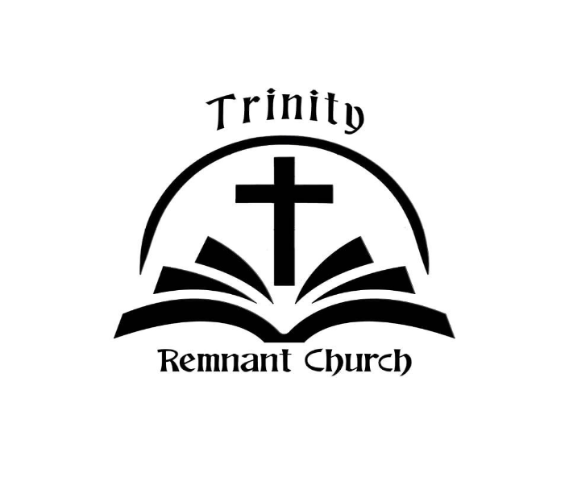

FEBRUARY 8, 2026

ROMANS 5:6-11

