July 26, 2026, Remnant Church 9:00 AM
* Call to Worship: (Psalm 92:1-2)
* Prayer of Invocation
* Singing: Hymn 75 – My Hope Is Built On Nothing Less
*God’s Greeting:
The Disciple's Prayer (Lord's Prayer) – Page 120
The Reading of God's Law: Mark 12: 28-31
The General Confession
- Public (Unison)- Page 120
- Individual (Silently)
- Prayer (Minister)
* Singing: Hymn 76 – What Can Wash Away My Sin?
The Apostle's Creed (Unison) – Page 121
Congregational Prayer
- Individual and Pastoral
* The Gloria Patri – Page 121
* Singing: Hymn 74 – My Faith Looks Up To Thee

Message: ROMANS 8:38-39, Sermon, and Prayer

* Singing: Hymn 77 – My Jesus, I Love Thee
*Doxology: Page 121 - Praise God from whom all blessings flow
*Benediction
*if you are able, please stand
CALL TO WORSHIP: PSALM 92:1-2

1 It is good to praise the Lord
and make music to Your name, O Most High,
2 proclaiming Your love in the morning
and Your faithfulness at night,

READING OF THE LAW: MARK 12: 28-31

28 One of the teachers of the law came and heard them debating. Noticing that Jesus had given them a good answer, he asked Him, “Of all the commandments, which is the most important?”
29 “The most important one,” answered Jesus, “is this: ‘Hear, O Israel: The Lord our God, the Lord is one. 30 Love the Lord your God with all your heart and with all your soul and with all your mind and with all your strength.’ 31 The second is this: ‘Love your neighbor as yourself.’ There is no commandment greater than these.”

SERMON TEXT: ROMANS 8:38-39
38 For I am convinced that neither death nor life, neither angels nor demons, neither the present nor the future, nor any powers, 39 neither height nor depth, nor anything else in all creation, will be able to separate us from the love of God that is in Christ Jesus our Lord.

CHURCH INFORMATION

Meeting Place: Pella Memorial Building
829 Broadway St Pella, IA 50219

Time: 9:00 AM

Phone: 641.858.6985

Email: pastor@trinityremnant.org

Parsonage Address: 535 Peoria Cross Street Pella, IA 50219

Website: www.trinityremnant.org

Our Commitment to God:

Doing ANYTHING for Him,
Going ANYWHERE for Him, and
Working ANYTIME for Him

Pastor: Benjamin Anum-Higher

TRINITY REMNANT CHURCH

PELLA, IA

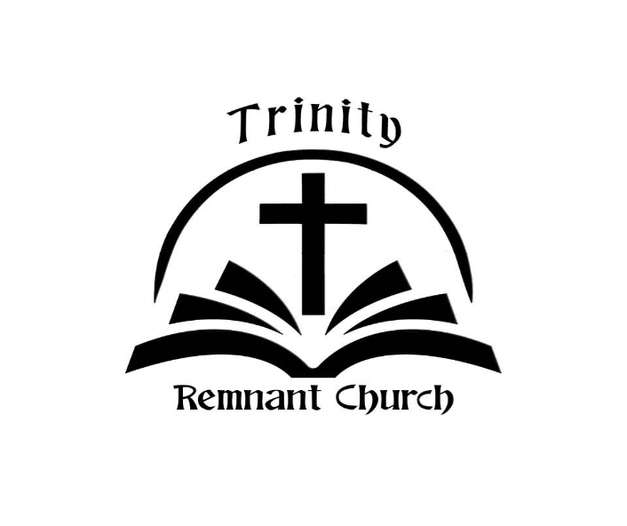

JULY 26, 2026

ROMANS 8:38-39

