December 21, 2025 Remnant Church 9:00 AM
* Call to Worship: (Psalm 150: 1-2)
* Prayer of Invocation
* Singing: Hymn 79 – Now Thank We All Our God
*God’s Greeting:
The Disciple's Prayer (Lord's Prayer) – Page 120
The Reading of God's Law: Exodus 20
The General Confession
- Public (Unison)- Page 120
- Individual (Silently)
- Prayer (Minister)
* Singing: Hymn 69 – Love Divine, All Loves Excelling
The Apostle's Creed (Unison) – Page 121
Congregational Prayer
- Individual and Pastoral
The Gloria Patri – Page 121
* Singing: Hymn 1 – A Debtor To Mercy Alone

Message: ROMANS 3:19-20, Sermon, and Prayer

* Singing: Hymn 78 – Not What My Hands Have Done
*Doxology: Page 121 - Praise God from whom all blessings flow
*Benediction
*if you are able, please stand
CALL TO WORSHIP: PSALM 150: 1-2

1 Praise the Lord. Praise God in His sanctuary;
praise Him in His mighty heavens.
2 Praise Him for His acts of power;
praise Him for His surpassing greatness.

SERMON TEXT: ROMANS 3: 19-20

19 Now we know that whatever the law says, it says to those who are under the law, so that every mouth may be silenced and the whole world held accountable to God.
20 Therefore no one will be declared righteous in God’s sight by the works of the law; rather, through the law we become conscious of our sin.

CHURCH INFORMATION

Meeting Place: Pella Memorial Building
829 Broadway St Pella, IA 50219

Time: 9:00 AM

Phone: 641.858.6985

Email: pastor@trinityremnant.org

Parsonage Address: 535 Peoria Cross Street Pella, IA 50219

Website: www.trinityremnant.org

Our Commitment to God:

Doing ANYTHING for Him,
Going ANYWHERE for Him, and
Working ANYTIME for Him

Pastor: Benjamin Anum-Higher

TRINITY REMNANT CHURCH

PELLA, IA

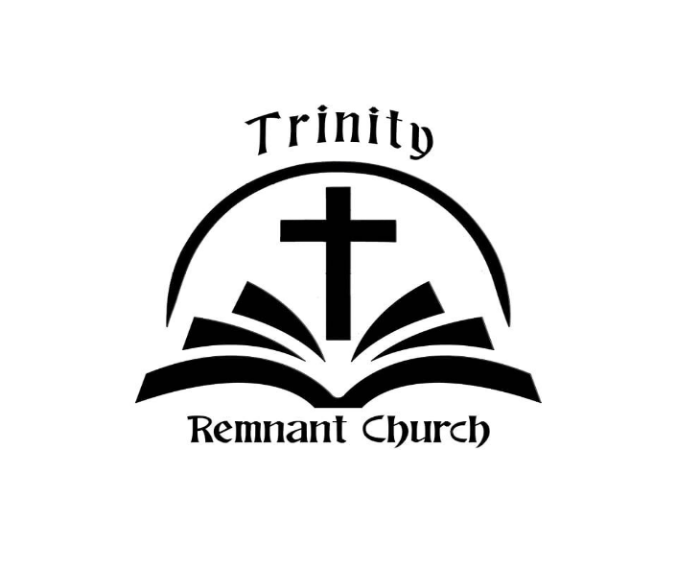

DECEMBER 21, 2025

ROMANS 3:19-20

