April 19, 2026, Remnant Church 9:00 AM
* Call to Worship: (1 Chronicles 16:29)
* Prayer of Invocation
* Singing: Hymn 20 – Christ The Lord Is Risen Today
*God’s Greeting:
The Disciple's Prayer (Lord's Prayer) – Page 120
The Reading of God's Law: Mark 12: 28-31
The General Confession
- Public (Unison)- Page 120
- Individual (Silently)
- Prayer (Minister)
* Singing: Hymn 17 – Blest Be The Tie That Binds
The Apostle's Creed (Unison) – Page 121
Congregational Prayer
- Individual and Pastoral
The Gloria Patri – Page 121
* Singing: Hymn 14 – Before the throne of God above

Message: ROMANS 8:5-11, Sermon, and Prayer

* Singing: Hymn 13 – Be Thou My Mision
*Doxology: Page 121 - Praise God from whom all blessings flow
*Benediction
*if you are able, please stand
CALL TO WORSHIP: 1 CHRONICLES 16:29

Ascribe to the Lord the glory due His name; bring an offering and come before Him. Worship the Lord in the splendor of His holiness.

READING OF THE LAW: MARK 12: 28-31

SERMON TEXT: ROMANS 8:5-11
5 Those who live according to the flesh have their minds set on what the flesh desires; but those who live in accordance with the Spirit have their minds set on what the Spirit desires. 6 The mind governed by the flesh is death, but the mind governed by the Spirit is life and peace. 7 The mind governed by the flesh is hostile to God; it does not submit to God’s law, nor can it do so. 8 Those who are in the realm of the flesh cannot please God.
9 You, however, are not in the realm of the flesh but are in the realm of the Spirit, if indeed the Spirit of God lives in you. And if anyone does not have the Spirit of Christ, they do not belong to Christ. 10 But if Christ is in you, then even though your body is subject to death because of sin, the Spirit gives life because of righteousness. 11 And if the Spirit of him who raised Jesus from the dead is living in you, he who raised Christ from the dead will also give life to your mortal bodies because of his Spirit who lives in you.

CHURCH INFORMATION

Meeting Place: Pella Memorial Building
829 Broadway St Pella, IA 50219

Time: 9:00 AM

Phone: 641.858.6985

Email: pastor@trinityremnant.org

Parsonage Address: 535 Peoria Cross Street Pella, IA 50219

Website: www.trinityremnant.org

Our Commitment to God:

Doing ANYTHING for Him,
Going ANYWHERE for Him, and
Working ANYTIME for Him

Pastor: Benjamin Anum-Higher

TRINITY REMNANT CHURCH

PELLA, IA

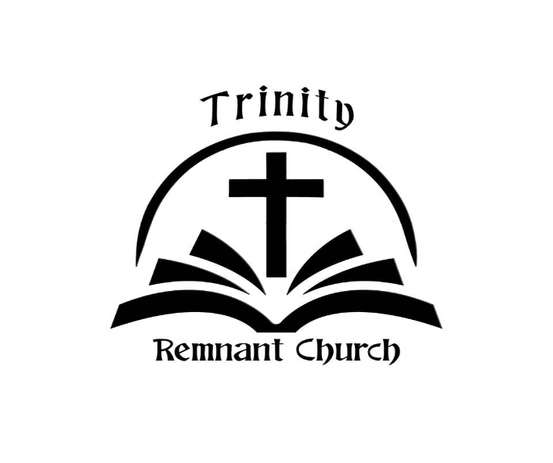

APRIL 19, 2026

ROMANS 8:5-11

