September 20, 2026, Remnant Church 9:00 AM
* Call to Worship: (Romans 10:13)
* Prayer of Invocation
* Singing: Hymn 110 – We Praise Thee, O God
*God’s Greeting:
The Disciple's Prayer (Lord's Prayer) – Page 120
The Reading of God's Law: Exodus 20
The General Confession
- Public (Unison)- Page 120
- Individual (Silently)
- Prayer (Minister)
* Singing: Hymn 109 – We Gather Together
The Apostle's Creed (Unison) – Page 121
Congregational Prayer
- Individual and Pastoral
* The Gloria Patri – Page 121
* Singing: Hymn 112 – Who Is He In Yonder Stall

Message: ROMANS 9:14-18, Sermon, and Prayer

* Singing: Hymn 111 – When I Survey
*Doxology: Page 121 - Praise God From Whom All Blessings Flow.
*Benediction
*if you are able, please stand
CALL TO WORSHIP: ROMANS 10:13

For “everyone who calls on the name of the Lord will be saved.”

READING OF THE LAW: EXODUS 20

God spoke all these words

1.You shall have no other gods before Me.
2. You shall not make for yourself an idol. You shall not bow down to them or worship them.
3. You shall not make wrongful use of the name of the Lord your God.
4. Remember the Sabbath day and keep it holy.
5. Honor your father and your mother.
6. You shall not murder.
7. You shall not commit adultery.
8. You shall not steal.
9. You shall not bear false witness against your neighbor.
10. You shall not covet your neighbor’s house; you shall not covet your neighbor’s wife, or male or female servant, or ox, or donkey, or anything that belongs to your neighbor.

SERMON TEXT: ROMANS 9:14-18
14 What then shall we say? Is God unjust? Not at all! 15 For He says to Moses, “I will have mercy on whom I have mercy, and I will have compassion on whom I have compassion.” 16 It does not, therefore, depend on human desire or effort, but on God’s mercy. 17 For Scripture says to Pharaoh: “I raised you up for this very purpose, that I might display My power in you and that My name might be proclaimed in all the earth.” 18 Therefore God has mercy on whom He wants to have mercy, and He hardens whom He wants to harden.

CHURCH INFORMATION

Meeting Place: Pella Memorial Building
829 Broadway St Pella, IA 50219

Time: 9:00 AM

Phone: 641.858.6985

Email: pastor@trinityremnant.org

Parsonage Address: 535 Peoria Cross Street Pella, IA 50219

Website: www.trinityremnant.org

Our Commitment to God:

Doing ANYTHING for Him,
Going ANYWHERE for Him, and
Working ANYTIME for Him

Pastor: Benjamin Anum-Higher

TRINITY REMNANT CHURCH

PELLA, IA

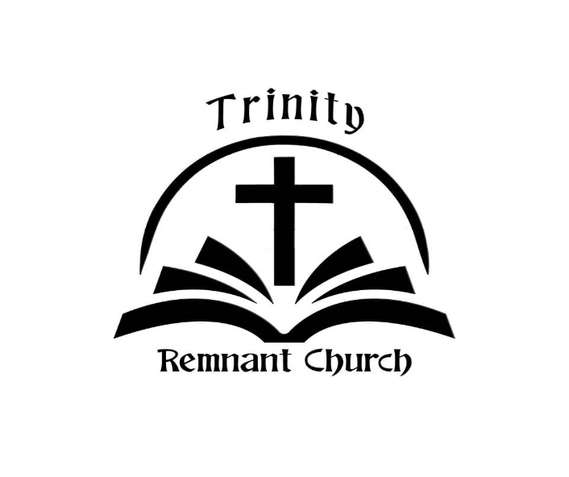

SEPTEMBER 20, 2026

ROMANS 9:14-18

